Project Design Phase-II
Data Flow Diagram & User Stories

Date | 26-05-2025
Team ID
Project Name | DocSpot – (Doctor Appointment System)
Maximum Marks | 4 Marks

Data Flow Diagrams:
A Data Flow Diagram (DFD) illustrates how data moves within the DocSpot platform. It captures how users (patients, doctors, and admins) interact with the system, how information flows between different components, and where the data is stored.
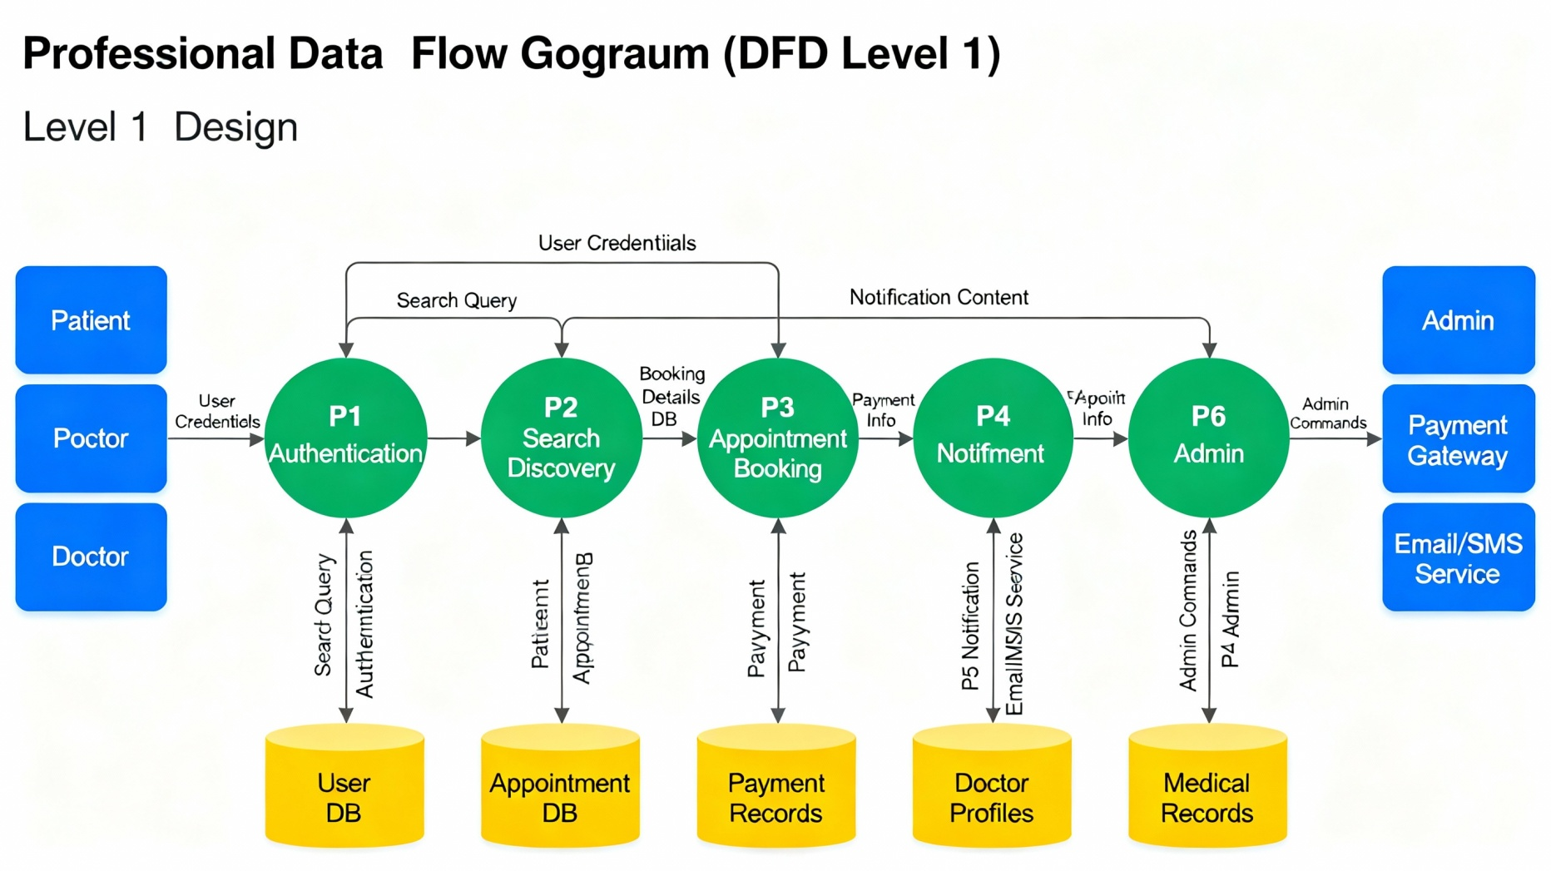

User Stories

User Story Table – DocSpot(Doctor Appointment System)
User Type | Functional Requirement (Epic) | User Story / Task | Acceptance Criteria | Priority | Release
Patient | User Authentication & Authorization | As a patient, I can register with email, password, and personal details. | Registration form displays, account created successfully. | High | Sprint-1
Patient | Appointment Booking & Management | As a patient, I can browse available doctors and time slots. | Doctor list displays with clear slot availability. | High | Sprint-3
Patient | Billing & Payments | As a patient, I can view appointment fees and generate invoices. | Invoice displays with itemized breakdown. | High | Sprint-4
Doctor | User Authentication & Authorization | As a doctor, I can register with credentials, qualifications, and specialization. | Registration form displays all fields, account created. | High | Sprint-1
Doctor | Doctor Management | As a doctor, I can update my profile (qualifications, experience, bio). | Profile updates saved successfully, changes visible. | Medium | Sprint-2
Doctor | Appointment Management | As a doctor, I can view my booked appointments. | Appointment list displays all bookings with patient details. | High | Sprint-3
Admin | User Authentication & Authorization | As an admin, I can log in with credentials and access admin dashboard. | Login successful, admin panel displays all options. | High | Sprint-1
Admin | Admin Management | As an admin, I can view all users (patients and doctors) in the system. | User list displays with filters, pagination works. | High | Sprint-4
Admin | Compliance & Audit | As an admin, I can view complete audit logs of all system actions. | Audit trail displays with timestamps and user details. | High | Sprint-4

